Graph Theory - Tutorial 6 Solutions
SMA116 – Discrete Mathematics 1B
Note: Only the final trees are given in the solutions below. You should show the tree at each stage in your answers.
Question 1
Apply the Depth First Search algorithm to each of the graphs in Figure 1. Include the tree at each stage in your answer and give the order in which the vertices are visited. Remember to use the alphabetic/numeric convention – this will tell you which vertex to start the algorithm at.
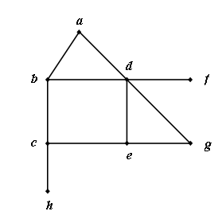
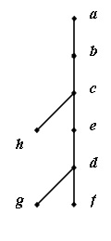
(a)
T
v | DFI(v)
a | 1
b | 2
c | 3
e | 4
d | 5
f | 6
g | 7
h | 8

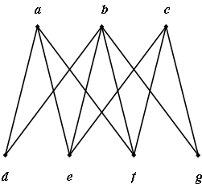
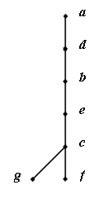
(b)
T
v | DFI(v)
a | 1
d | 2
b | 3
e | 4
c | 5
f | 6
g | 7

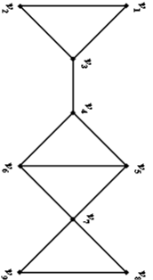  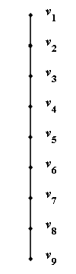  v  (c)  T | DFI(v)
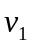 | 1
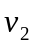 | 2
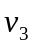 | 3
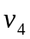 | 4
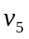 | 5
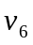 | 6
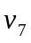 | 7
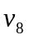 | 8
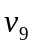 | 9

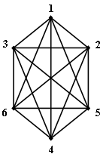
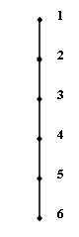
(d)
T
v | DFI(v)
1 | 1
2 | 2
3 | 3
4 | 4
5 | 5
6 | 6

Figure 1
Question 2
Identify the cross edges and back edges (where they exist) for each of the graphs in Figure 1, as determined by your DFS spanning tree.
Note that DFS trees never have cross edges. The back edges for each of the trees in question 1 are as follows (and include all edges in the original graph not included in the tree):
- 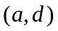, 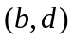, 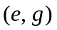.
- 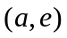, 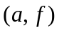, 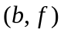, 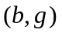.
- 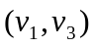, 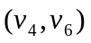, 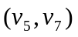, 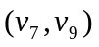.
- (1, 3), (1, 4), (1, 5), (1, 6), (2, 4), (2, 5), (2, 6), (3, 5), (3, 6), (4, 6).
Question 3
Apply the Breadth First Search to each of the graphs in Figure 1. Include the tree at each stage in your answer and give the order in which the vertices are visited.
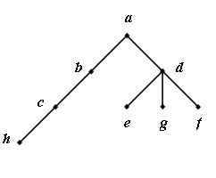
(a)
T
v | BFI(v)
a | 1
b | 2
d | 3
c | 4
e | 5
f | 6
g | 7
h | 8
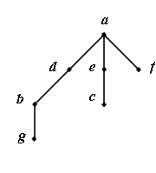
(b)
T
v | BFI(v)
a | 1
d | 2
e | 3
f | 4
b | 5
c | 6
g | 7
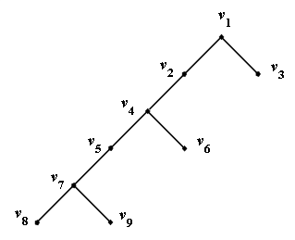
v | DFI(v)
 | 1
 | 2
 | 3
 | 4
 | 5
 | 6
 | 7
 | 8
 | 9
T
(c)

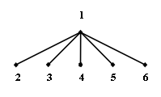  v  (d)  T | BFI(v)
1 | 1
2 | 2
3 | 3
4 | 4
5 | 5
6 | 6
Question 4
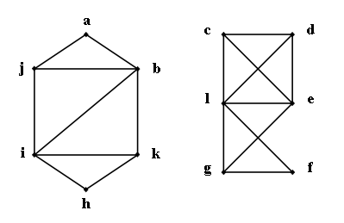
Apply the DFS algorithm to the graph in figure 2. Note that each component will have to be handled separately.

Figure 2
v | DFI(v)
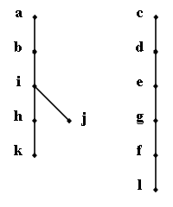  a  F | 1
b | 2
i | 3
j | 4
h | 5
k | 6
c | 7
d | 8
e | 9
g | 10
f | 11
l | 12

